Instructions

Allowed tools: Paper, pen and dictionary.

Write name and personal number on THIS page and the secret number given to you by Rauan/Kristoffer on EVERY page.

If you want your result sent to you be email write your email address here:

Maximum number of points on the exam is 100.
If the project has been performed properly Question 1 can be skipped and full points will be given.
If all assignments have been submitted in a final form Question 2 can be skipped and full points will be given.
See separate lists for this.

Grades are accordingly to the following
A 92-100
B 80-91
C 68-79
D 56-67
E 50-55
Fx 45-49
F 0-44

Each question should be answered within the provided space, if you
need more space write on the back of the paper.

You can answer in either English or Swedish

Arne can be reached at 070-6951045 for questions, and will pass by at a few times.

Short questions (10 p per question):

1. Align these two sequences, AACGGTGA and GACATGA using an identity matrix and a zero gap-penalty. Show the entire alignment procedure. What is the score ? How will the alignment and score change if you use a gap-penalty of -1 ?

2. (A) The amino acid proline is shown below. Proline is a strong helix breaker – why? (5 p)
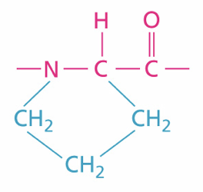

(B) Why do methods that use multiple sequence alignments generally work better for secondary structure prediction methods than single-sequence based methods? (5 p).

3. Describe how the membrane-protein topology prediction method TOPPRED works based on the two figures below (10 p).

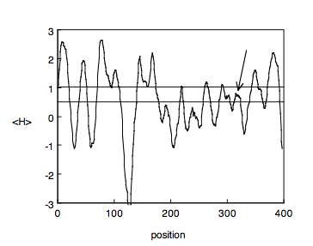
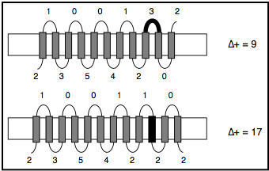

4. Performance figures from machine learning methods are often displayed in form of graphs where sensitivity is plotted as a function of specificity or true positive rate (TPR) is plotted as function of false positive rate (FPR). Why are these plots preferred over reporting single values of i.e. TPR and FPR?

5. Fasta and Blast are so called heuristic methods. What does that mean? (5p) They are significantly faster than dynamic programming based methods. How is this achieved? (5p)

6. Describe the steps necessary to make a good homology model. (5p) What are the most crucial steps for the quality of the final model? (5p)
7. How is the E-value in sequence alignment dependent on the score and the database size?
8. What is the difference between a parsimonious and a neighbor joining method in phylogeny ?

Long question (20 p per question):
9. Describe how you would develop a predictor that is able to identify the interaction areas between two proteins. What methods would you use? What are the important data you can use? How would you develop the pipeline? Describe potential problems. What proteins are easier to predict ?

