Instructions

Allowed tools: Paper, pen and dictionary.

Write name and personal number on THIS page and the secret number given to you by Kristoffer on EVERY page.

If you want your result sent to you be email write your email address here:

Maximum number of points on the exam is 100.
If the project has been performed properly Question 1 can be skipped and full points will be given.
If all assignments have been submitted in a final form Question 2 can be skipped and full points will be given.
See separate lists for this.

Grades are accordingly to the following
A 92-100
B 80-91
C 68-79
D 56-67
E 50-55
Fx 45-49
F 0-44

Each question should be answered within the provided space, if you need more space write on the back of the paper.

You can answer in either English or Swedish

Arne can be reached at 070-6951045 for questions.

Short questions (10 p per question):

- Describe two different methods used to create phylogenetic trees.
- Illustrate schematically the HMM architecture used in profile-HMMs (such as HMMER and SAM). (5p) How is a HMM trained (5p) ?

- Describe PSIBLAST, BLAST, FASTA and Smith-Waterman. Make a table where you rank the speed and sensitivity of the four methods.
- Describe the differences between discriminative models and generative models.

- We have used several different bioinformatics databases throughout the course, and some of the most common ones are Genbank, Uniprot/Swissprot, PDB, and Pfam. For each of these, describe briefly what data it actually contains, advantages (when/why it is useful) and disadvantages. (10p)
- What is the “out of Africa hypothesis” and what is the “bioinformatical/genomic” evidence for it ? (10p)

- (A) In which state(s) in the TMHMM architecture below are the emission probabilities for Trp and Tyr especially high? (5 p)

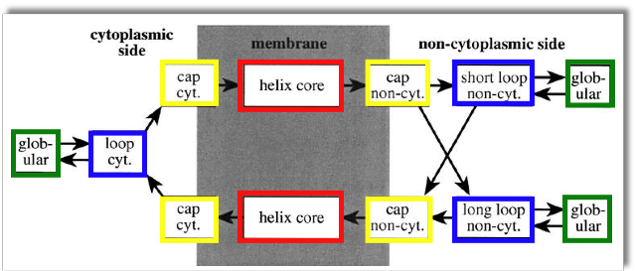

(B) In the figure below (which shows the integral membrane protein aquaporin), there are residues colored in green and in blue. What types of residues are these? (5p)
- (A) How many degrees of freedom (e.g., angles) do you need to describe the back-bone conformation of a protein chain of length N residues? (5p)

(B) Indicate the location of α-helices and β-strands on the Ramachandran plot. (5p)

Long question (20 p per question):
9. You are asked to analyze a set of RNA-seq data from cancer- and non-cancer (healthy) cells to evaluate if it is possible to use this data to identify cancer and non-cancer cells as well as the cancer type. One problem is that only for a fraction of the cells
you know the cancer type. Describe how you should address this problem, using the classified and unclassified cell types. What type of classification algorithms would you use?

